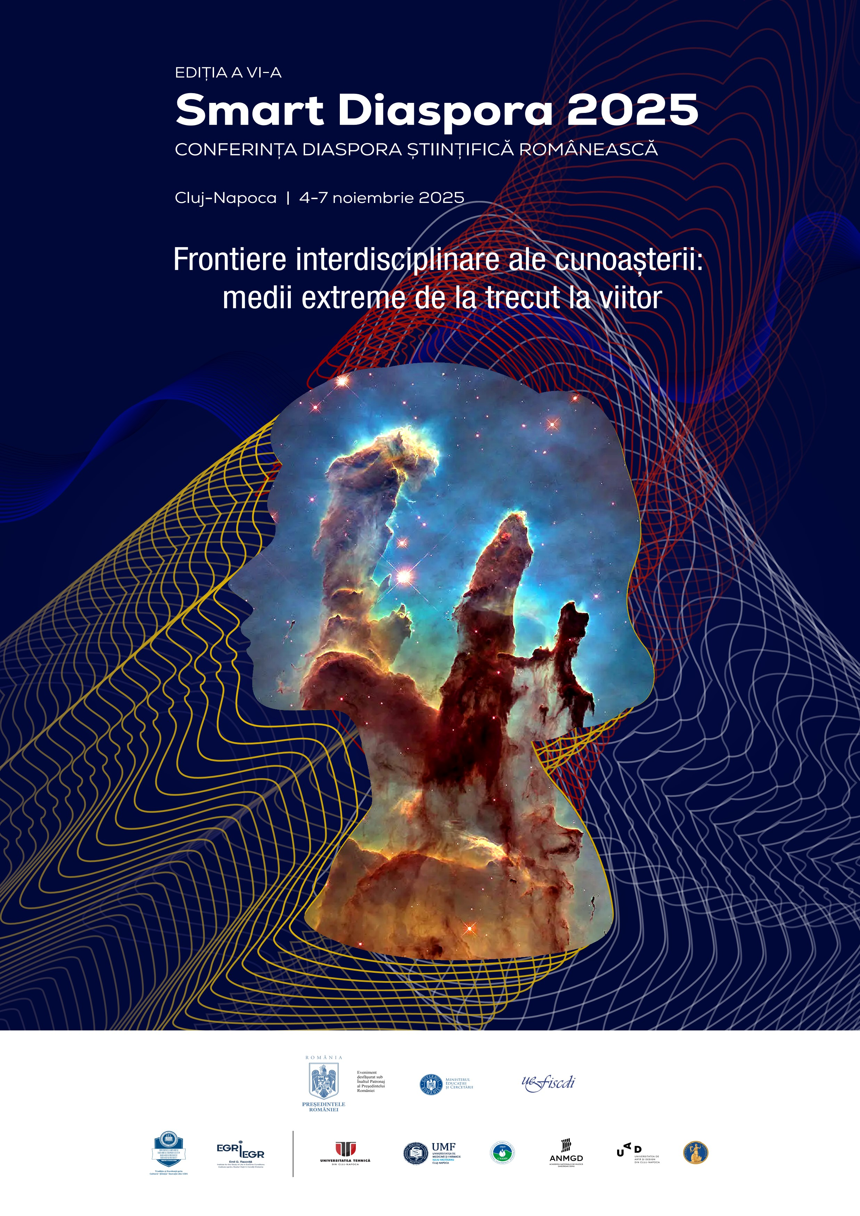

workshop Frontiere interdisciplinare ale cunoașterii: medii extreme de
la trecut la viitor (Interdisciplinary Frontiers of
Knowledge:
Sala/Room Extreme
103 Environments from _{Past to Future)}
FSEGA, Str. Teodor Mihali, Nr. 58-60 Înregistrarea participanților are loc în sala 103

Miercuri, 5 noiembrie 2025

09:00-09:10 Ioana-Nicoleta Meleg
Universitatea Babeș-Bolyai, România
Welcome and workshop opening

9:10-11:00
Outer space and inner Earth: extreme environments and technological frontiers / Spațiul cosmic
și interiorul Terrei: medii extreme și frontiere tehnologice
Chair: Ioana-Nicoleta Meleg 9:10-09:40

Răzvan Caracas

Institut de Physique du Globe de Paris, Franța
Large and giant impacts in the early solar system / Impacturi mari și gigantice în sistemul solar timpuriu

09:40-10:10 Laurențiu Nicolae

European Space Agency, Țările de Jos
The Lunar Environment – A Proving Ground for Space Technologies / Luna – terenul de testare al limitelor
tehnologiei 10:10-10:40

Mihai Ducea

Universitatea București, România
Drilling into magma for energy purposes – discoveries, directions and potential / Foraj în magmă în scopuri energetice – descoperiri, direcții și potențial

10:40-11:00

Claudiu Tănăselia

Institutul Național de Cercetare Dezvoltare pentru Optoelectronică INOE 2000, Cluj-Napoca, România
Analytical investigations on the Romanian meteorites Mocs and Pleșcoi / Investigații analitice asupra meteoriților românești Mocs și Pleșcoi 11:00-11:30
Pauză cafea / Etajul 1, Clădirea FSEGA

11:30-12:30
Extreme deep-time transitions and the quest for chronological precision / Tranziții extreme în trecutul geologic îndepărtat și provocări privind precizia cronologică
Chair: Anca Avram 11:30-12:00 Liviu Matenco

Universiteit Utrecht, Țările de Jos
The framework of the deep-time extreme changes and events / Cadrul schimbărilor și evenimentelor extreme în trecutul geologic îndepărtat

12:00-12:30

Ioan Francovschi
Universitatea de Stat din Moldova, Institutul de Geologie și

Seismologie, Republica Moldova
Accessing the Ediacaran-Cambrian boundary in SW Baltica based on SHRIMP and CA-ID-TIMS zircon U-Pb dates / Studiul limitei Ediacaran-Cambrian din SV Balticii pe baza
datărilor U-Pb pe zircoane prin metodele SHRIMP și CA-IDTIMS
12:30-14:00 Prânz / Etajul 1, Clădirea FSEGA

14:00-15:30
Extreme changes in deep time: microfossils, biogeochemical proxies, and carbon systems / Schimbări extreme în trecutul geologic îndepărtat: microfosile, indicatori biogeochimici și sisteme de carbon
Chair: Dorina Podar 14:00-14:15

Artur Ionescu

Universitatea Babeș-Bolyai, România
Decoding deep carbon emissions: The Carpathian Mountains as a natural laboratory for extreme CO₂ environments / Descifrarea emisiilor de carbon din
profunzime: Munții Carpați – un laborator natural al mediilor extreme de CO₂

14:15-14:30

Ramona Balc
Universitatea Babeș-Bolyai, România From discovery to data: The role of calcareous nannoplankton in geological sciences / De la descoperire la date: rolul nanoplanctonului calcaros în științele geologice

14:30-20:00

Exploring Micro-Worlds: Trends and discoveries in microbial adaptations and roles in extreme ecosystems / Explorarea lumii microscopice: tendințe și descoperiri privind adaptările și rolurile microorganismelor în ecosisteme extreme
Chair: Horia Banciu 14:30-15:00

Danny Ionescu

Technische Universität Berlin, Germania
The Dead Sea and its secrets / Marea Moartă și secretele sale

15:00-15:30

Corina Ițcuș
Institutul de Biologie București al Academiei Române, România Warming Ice: Climate-driven shifts in microbial communities of frozen ecosystems / Gheața în încălzire: modificări induse de schimbarea climatică în comunitățile microbiene din ecosistemelele înghețate
Smart Diaspora 2025
15:30-16:00 Pauză cafea / Etajul 1, Clădirea FSEGA

16:00-16:30

Mircea Podar

Oak Ridge National Laboratory, Statele Unite ale Americii
Exploring microbial frontiers through genomics and metagenomics - from the human ecosystem to the extremes of life / Integrarea informației genomice și metagenomice pentru investigarea frontierelor microbiene
– de la ecosistemul uman la mediile extreme

16:30-17:00 Niculina Mușat

Universitatea Aarhus, Danemarca
Probing rare physiological traits of environmental microorganisms through Isotopic Labeling and HighResolution Chemical Imaging / Identificarea trăsăturilor fiziologice rare ale microorganismelor din mediu prin sondare izotopică și imagistică chimică de înaltă rezoluție 20:00
Eveniment de networking la nivel de workshop
(Euphoria Biergarten, str. Cardinal Iuliu Hossu, nr. 25 )

Joi, 6 noiembrie 2025

09:45-11:00
Climate and vegetation shifts: insights from the past and present / Schimbări climatice și de vegetație: perspective din trecut și prezent
Chair: Mihai Pușcaș 09:45-10:15 Angelica Feurdean

Goethe University, Germania
Cold-Region vegetation in a warmer past / Vegetația din regiunile reci într-un trecut mai cald

10:15-10:45 Ovidiu Păun

University of Vienna, Austria
Resilience at the extremes: epigenetic responses of highalpine plants to a warmer world / Reziliența în condiții extreme: răspunsurile epigenetice ale plantelor alpine la schimbările climatice 10:45-11:00 Pavel Dan Turtureanu

Universitatea Babeș-Bolyai, România
Shrub expansion as a key driver of mountain greening in the Carpathians / Expansiunea arbuștilor ca factor principal al înverzirii montane în Carpați 11:00-11:30
Pauză cafea / Etajul 1, Clădirea FSEGA

11:30-12:30
Mapping and managing environmental extremes: from karst systems to EU Strategies / Cartografierea și gestionarea extremelor de mediu: de la sistemele carstice la strategiile UE
Chair: Ioana-Nicoleta Meleg

11:30-12:00

Magdalena Năpăruș-Aljančič

Karst Research Institute ZRC SAZU, Slovenia
Mapping extremes in karst: databases, portals and research infrastructures / Cartografierea extremelor în carst: baze de date, portaluri și infrastructuri de cercetare

12:00-12:30

Andreea Niță

University of Granada, Spania
Environmental assessment in complex networks for the integration of European policies addressing extreme environment challenges / Evaluarea mediului în rețele complexe, în vederea integrării politicilor europene pentru a răspunde provocărilor mediilor extreme 12:30-14:00
Prânz / Etajul 1, Clădirea FSEGA

14:00-15:20
Shaped by nature: caves, climate, and cultural resilience / Modelate de natură: peșteri, climă și
reziliență culturală
Chair: Horia Banciu 14:00-14:30

Liviu Giosan
Woods Hole Oceanographic Institution, Statele Unite ale Americii Civilizations as adaptation to environment / Civilizațiile umane - Forme de adaptare la mediu

14:30-15:00

Vasile Ersek

Northumbria University, Marea Britanie
Caves, climate and civilisations: Lessons from the past about the future of water / Peșteri, climă și civilizații: lecții
din trecut pentru viitorul apei

15:00-15:20

Andrea Demjén

Muzeul Național de Istorie a Transilvaniei, România
From shelter to sacred space: cave environment and ancient funerary traditions at Toplița de Vida (Romania) / De la adăpost la spațiu sacru: mediul subteran și tradițiile funerare străvechi de la Toplița de Vida (România) 15:20-16:00
Pauză cafea / Etajul 1, Clădirea FSEGA

16:00-20:00
Nature-based and technological solutions for extreme environmental degradation / Soluții bazate pe natură și tehnologii pentru combaterea degradării extreme a mediului
Chair: Iulia Lupan 16:00-16:30

Sergiu Dobrojan
Universitatea de Stat din Moldova, Republica Moldova Interdisciplinary frontiers of knowledge: recycling aquaculture wastewater for growing algae used as food for fish – joint action Romania – Republic of Moldova / Frontiere interdisciplinare ale cunoașterii: reciclarea apelor reziduale din acvacultură pentru cultivarea algelor folosite ca hrană pentru pește – acțiune comună România – Republica Moldova

16:30-16:45

Daniela Borda
Institutul de Speologie “Emil Racoviță” al Academiei Române Filiala

Cluj, România

A simple and low-cost method for monitoring gold mine pollution / O metodă simplă și rentabilă de monitorizare a poluării minelor de aur 16:45-17:00 Lorena Cristina Văcar

Universitatea Babeș-Bolyai, România
From pollution to solution: The study of heavy metalresistant fungi for bioremediation / De la poluare la
soluție: studiul ciupercilor rezistente la metale grele pentru
bioremediere 20:00
Cină festivă (Wild Hills, E576, Juc-Herghelie)
Smart Diaspora 2025

Ramona Bălc is a researcher specializing in micropaleontology, with a focus on calcareous nannoplankton. Her work aims to determine the age of sedimentary sequences and reconstruct the paleoecological conditions under which they were deposited, contributing to local, regional, and global stratigraphic correlations. Calcareous nannoplankton are a valuable tool for sediment dating - from the Triassic to the present - due to their excellent preservation, widespread distribution, and abundance. Her research also integrates data from other fossil groups, such as foraminifera, bivalves, fish, and marine vertebrates, to provide a more comprehensive understanding of Earth’s geological past.

Interdisciplinary frontiers of knowledge: extreme environments from past to future November 4-7, 2025 - Cluj-Napoca

From discovery to data: the role of calcareous nannoplankton in geological sciences
Ramona Bălc^{1*}
¹ Babeș-Bolyai University, Faculty of Environmental Science and Engineering, 30 Fântânele Street,
Cluj-Napoca 400294; ramona.balc@ubbcluj.ro

Key words: calcareous nannoplankton, evolution, coccoliths, biostratigraphy, palaeoecology

Calcareous nannofossils are the minute remains of planktonic algae, with their living counterparts known as calcareous nannoplankton. This diverse group, ranging from 2 to 63 µm in size, encompasses coccoliths, nannoliths, and calcispheres. Among them, coccolithophores are unicellular algae belonging to the class Prymnesiophyceae within the division Haptophyta. As photosynthetic organisms, they thrive in the ocean’s photic zone, typically within the upper 50-200 meters of the water column (Jordan and Chamberlain, 1997).
The study of calcareous nannoplankton has evolved from a descriptive curiosity into a cornerstone of modern geological sciences, providing critical insights into Earth’s history and processes. Since their discovery in the mid-19th century (Mutterlose et al., 2005), these microscopic calcite-secreting algae (Gardin et al., 2012) have fascinated researchers both for their delicate morphologies and for the wealth of paleoenvironmental information they preserve in the geological record. With a fossil record extending back to the Late Triassic, calcareous nannoplankton are among the most abundant and continuous sedimentary microfossils, making them exceptionally valuable biostratigraphic tools (Mutterlose et al., 2005). Their rapid evolutionary rates and broad geographic distribution enable high-resolution correlations across marine sediments, allowing geologists to refine chronostratigraphic frameworks with remarkable precision.
Beyond stratigraphy, calcareous nannoplankton provide a direct archive of paleoceanographic and paleoclimatic conditions. The composition, abundance, and preservation of nannofossil assemblages reflect variations in surface water temperature, productivity, sediments chemistry, and ocean circulation. Stable isotope analysis and coccolith calcification studies have further deepened our understanding of past carbon cycle dynamics, including episodes of ocean acidification, greenhouse-icehouse transitions, and mass extinction events. As primary producers, coccolithophores also continue to play a vital role in regulating modern marine ecosystems and the global carbon pump (Gardin et al., 2012), linking their fossil record with ongoing climate change research.
The progression from discovery to data has been driven by advances in microscopy, taxonomy, and digital methods. Early light microscope observations gradually gave way to scanning electron microscopy, enabling precise morphological classification. Today, automated imaging, quantitative morphometrics, and machine learning are accelerating the pace of data acquisition, reducing observer bias, and opening new avenues for large-scale biogeographic and evolutionary studies. The integration of calcareous nannoplankton datasets into stratigraphic databases and climate models underscores their relevance not only for academic research but also for applied fields such as petroleum exploration, where accurate age determination and paleoenvironmental reconstructions are crucial.
In conclusion, calcareous nannoplankton exemplifies the journey of a microfossil group from initial discovery through methodological refinement to their establishment as indispensable tools for geological sciences. They bridge the gap between microscopic biological processes and global Earth system changes, offering one of the most detailed archives of Mesozoic and Cenozoic history (Mutterlose et al., 2005). As analytical techniques continue to advance, the role of calcareous nannoplankton is poised to expand further, reinforcing their importance in decoding Earth’s past and anticipating its future.

References
Gardin, S., Krystyn, L., Richoz, S., Bartolini, A. & Galbrun, B. 2012. Where and when the earliest coccolithophores? -Lethaia, 45, 507-523. https://doi.org/10.1111/j.1502-3931.2012.00311.x
Jordan, R.W. & Chamberlain, A.H.L .1997. Biodiversity among haptophyte algae. Biodiversity and Conservation, 6, 131-152. https://doi.org/10.1023/A:1018383817777
Mutterlose, J., Bornemann, A. & Herrle, J.O. 2005. Mesozoic calcareous nannofossils – state of the art.
Paläontologische Zeitschrift, 79(1), 113-133. https://doi.org/10.1007/BF03021757

Daniela (Borda) Cociuba is a biologist and scientific researcher at the “Emil Racoviță” Institute of Speleology, Cluj-Napoca Department (Romanian Academy). Her research focuses on two main areas: (1) the biology, ecology, and distribution of bats in Romanian caves, and (2) the impact of pollution and anthropogenic activities on the underground environment and karst aquifers.

Her work is characterized by an interdisciplinary approach at the intersection of subterranean biology, microbiology, climatology, and geology. Within these directions, she has investigated topics such as airborne microorganisms in cave environments, the aerosolization potential of guano deposits, the role of bats in microbial dispersion, bacterial dynamics in karst waters, the influence of climate on the selection of underground habitats, and population variations in bats.

Her studies also include analyses of geological structure and lithology, which influence groundwater chemistry, karst drainage systems, and the dynamics of microbial and invertebrate communities in karst aquifers.

Interdisciplinary frontiers of knowledge: extreme environments from past to future November 4-7, 2025 - Cluj-Napoca

A simple and low-cost method for monitoring gold mine pollution
Daniela R. Borda^{1*}, Ioan Cociuba², Delia C. Papp², Nicolae Cruceru³, Ruxandra M.
Bucur^{1,} Ioana N. Meleg^{3.4}
- Romanian Academy Cluj-Napoca Branch, “Emil Racoviță” Institute of Speleology, 5-7 Clinicilor Street, 400006 Cluj-Napoca, Romania, daniela.r.cociuba@gmail.com
- Geological Institute of Romania, 1 Caransebes, Street, 012271 Bucharest, Romania
- “Emil Racoviță” Institute of Speleology, Romanian Academy, 13 Calea 13 Septembrie Street,
050711 Bucharest, Romania
- Emil G. Racoviță Institute, Babes-Bolyai University, 5-7 Clinicilor Street, 400006 Cluj-Napoca, Romania

Key words: gold mining pollution, culturable microbiota, water invertebrates, site geology

Gold mining pollution has long-lasting effects on the environment, particularly through acid mine drainage and heavy metal contamination. Monitoring and assessing the impact of this pollution, as well as evaluating the effectiveness of remediation efforts, are crucial.
We present results from a monitoring study in the gold mining area of Zlatna (Romania), along with comparative findings from other karst areas. In our studies, we conducted on-site measurements of water temperature, pH, electrical conductivity, and dissolved oxygen, and quantified culturable aerobic bacteria and microfungi using ready-to-use media plates. We also examined the taxonomic richness of water invertebrates and the environmental features of the sites.
We found significant negative impacts on aquatic biota in mining areas, with microbial abundance proving to be a reliable indicator of acid mine drainage pollution. Although water invertebrates can also serve as indicators of mining effects, their abundance alone may not always accurately reflect pollution levels across sites. Multiple-factor analysis highlighted the influence of water type, geological characteristics, air temperature, and precipitation on the structure of aquatic communities.
We observed a natural attenuation of mining pollution in the Zlatna area over the past seven years. The results were interpreted within a broader context of chemical and organic pollution across the hydrological continuum, encompassing both surface and groundwater systems in karst and non-karst environments.
Our findings indicate that integrating basic water physicochemical parameters with microbiota quantification and invertebrate community assessments provides a simple, cost-effective alternative to conventional, expensive monitoring methods for evaluating gold mining pollution.
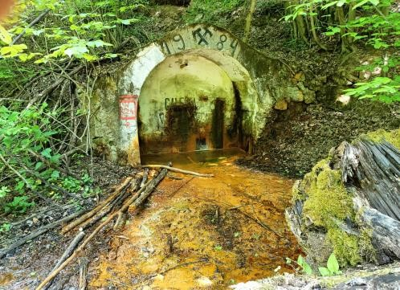
Figure 1. Valea Babei closed mine, gold mining area of Zlatna
Acknowledgements: This work was financially supported by the “Emil Racoviță” Institute of Speleology within Projects 3 and 5 of the Program’s 2021–2025 framework. The field samplings in 2015 were funded by CCCDI–UEFISCDI project 3-004/2014, Tools for sustainable gold mining in the EU (SUSMIN). Part of the undertaken statistical analyses were funded by a grant from the CNCS/CCCDI– UEFISCDI, project PN-III-P4-ID-PCE-2020-0518-P.

Reference
Borda DR, Cociuba I, Cruceru N, Papp DC, Meleg IN. A Cost-Effective and Straightforward Approach for Conducting Short- and Long-Term Biomonitoring of Gold Mine Waters. Water. 2023; 15(16):2883.

Răzvan Caracas is a mineralogist who uses computational techniques from solidstate physics and chemistry to study the behavior of geological materials under extreme thermodynamic and thermochemical conditions. His research covers a wide range of topics in planetary mineralogy, from shock physics and the supercritical state that dominated the protolunar disk to the internal structure of exoplanets. Through atomistic simulations, he seeks to understand Earth’s evolution during its first billion years, decipher the formation and evolution of the primitive atmosphere, and explore the conditions planets must meet to enable the development of prebiotic chemistry. He is currently a CNRS researcher at the Institut de Physique du Globe de Paris (IPGP), France.

Large and giant impacts in the early solar system
Razvan Caracas¹
¹Institut de Physique du Globe de Paris, Université Paris Cité, CNRS caracas@ipgp.fr

Key words: shock physics, ab initio, early Earth, planet formation, Moon

Giant and large-scale impacts dominate the end of the accretion stage in early solar systems. As the accretion advances, the size of the leftover planetesimals increases and, therefore, the impacts between them become increasingly energetic. Here we use atomistic simulations based on ab initio molecular dynamics and machine learning to study the behavior under shock of a series of silicates, representative of various rocky worlds, like the bulk silicate Earth (BSE) and several chondritic compositions. We calculate the entropy production during shock and relate it to the accretion history of the rocky planets. We show that many impacts have been sufficiently energetic to produce at least partial vaporization. This has tremendous effects to the transport of volatiles towards the inner part of the solar system.
In the specific case of our planet, the last major accretion event was the Moon-forming giant impact. The outcome of this impact was the formation of a large supercritical protolunar disk. The atomic structure of the silicate fluid varies with the radius within the disk due to strong pressure and temperature gradients. Fluffy short-lived chemical species dominate the outer parts of the disk, and long-lasting dense polymers abound in the deeper parts. At the beginning of its separation in the center of the disk, the Earth, and most rocky planets, will traverse a temporary state that lacks a surface defined by a magma ocean-atmosphere boundary. During further cooling, liquids and gases separate according to the liquid-vapor stability dome. The liquid droplets rain toward the center, contributing to the planet’s growth, which takes place in a state of a magma ocean (MO). The leftover gas forms the hot dense disk atmosphere.
We compute the chemical structure and the properties of the disk (Figure 1) and the composition of the disk atmosphere. We find the atmosphere to be extremely rich in molecular species, dominated by oxidized phases like SiO, O, O2, MgO, and cations like Na and Mg. But a plethora of other phases are present in the system, with lifetimes that allow them to play a role in the chemical and isotopic exchanges. Many of the gas molecules that we find in our simulations are not present in thermodynamic databases suggesting that a huge field of investigation lies bare ahead of us.
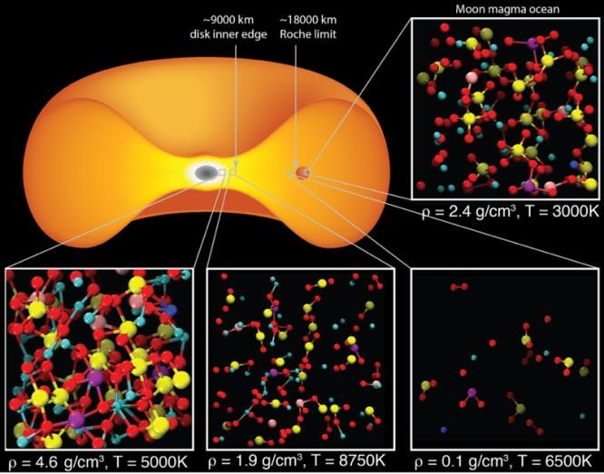
Figure 1. The chemical structure in the pyrolytic fluid changes with the widely-varying pressures and temperatures in the disk after a giant impact.
Acknowledgements: This research is funded by the ERC IMPACT, and the HIDDEN NFR projects.

References
Caracas, R. & Stewart S.T. 2023. No magma ocean surface after giant impacts between rocky planets, Earth and
Planet Sci. Lett., 608, 118014. DOI : 10.1016/j.epsl.2023.118014
Andrea Demjén is a museum curator at the National Museum of Transylvanian History and a research scientist at Babeș-Bolyai University - the “Emil G. Racoviță” Institute for the Study of Life in Extreme Conditions (Cluj-Napoca, Romania). Her research focuses on medieval, premodern, and early modern archaeology in the Transylvanian region, with a particular emphasis on historical archaeology and interdisciplinary approaches to cultural heritage. In her work, she combines classical archaeological analysis with modern investigative methods, contributing to the development of an integrated perspective on historical processes.

From shelter to sacred space: cave environment and ancient funerary traditions at Toplița de Vida (Romania)

Andrea Demjén¹, Florin Gogâltan², Szilárd S. Gál³, Adrienn Lőrincz⁴, Călin Ghemiș⁵,
Viorel T. Lascu⁶, Bogdan P. Onac^{7,8}, Ioana N. Meleg^{8,9*}

¹National Museum of Transylvanian History, C. Daicoviciu 2, 400020 Cluj-Napoca, Romania
²Institute of Archaeology and Art History, Kogălniceanu 12-14, 400084 Cluj-Napoca, Romania
³Mureș County Museum, Str. Mărăşti 8A, 540329 Târgu Mureş, Romania
⁴University of Debrecen, Egyetem tér 1, 4032 Debrecen, Hungary
⁵Criș Country Museum, Calea Armatei Române 1A, 410087 Oradea, Romania
⁶National Institute for Research and Development in Environmental Protection, 060031 Bucharest,
Romania
⁷School of Geosciences, University of South Florida, 4202 E. Fowler Ave., Tampa 33620, USA
⁸Emil G. Racoviță Institute, Babeș-Bolyai University, Clinicilor 5-7, 400006, Cluj-Napoca, Romania, ioana.meleg@ubbcluj.ro
⁹Emil Racoviță Institute of Speleology of the Romanian Academy, Calea 13 Septembrie 13, 050711,
Bucharest, Romania
Key words: burial, Early Bronze Age, Early Copper Age, Mesolithic, Middle Neolithic

Caves have held a significant place in human history, functioning as shelters, storage sites, and spaces for ritual practices. This study focuses on Toplița de Vida Cave, located in the Pădurea Craiului Mountains, part of the Apuseni Mountains in northwestern Romania. Spanning five millennia, from the Mesolithic to the Early Bronze Age (9000–4300 calibrate years BP, cal BP), the archaeological and paleoenvironmental evidence from this site provides a unique perspective on the lives, subsistence strategies, and cultural practices of the communities that inhabited or utilized the cave.
The oldest deposition level, dated to approximately 9000 cal BP (Mesolithic period), contains charcoal and charred seeds, indicating the earliest presence of humans in this cave. Two thousand years later, during the Middle Neolithic (ca. 7000 cal BP), charred seeds of barley (Hordeum vulgare), rye (Secale cereale), lentil (Lens culinaris), and pea (Pisum sativum) were discovered on the cave floor and inside ceramic pots. Uranium-series dating of a calcite crust on one of the ceramic pots near the seeds suggests a minimum age of 5500 years, corroborating with the seeds' estimated age. This level was associated with a fireplace and also yielded two stone axes. This evidence implies that during the Middle Neolithic, humans used the cave as a shelter or possibly for ritual purposes.
Near the cave entrance, ceramics from the Early Copper Age, associated with the Tiszapolgár Culture, were discovered alongside a boar canine dated to 6300 cal BP.
The most recent human occupation wave dates to the Early Bronze Age (4500–4300 cal BP). It is represented by human remains and contemporary fauna, including boars, wolfs, and caprines. An in situ assessment identified the remains of 30 individuals: 19 adults and 11 children. Most remains were found in secondary positions due to natural or human disturbances and exhibited signs of trauma, disease (e.g., tuberculosis, meningitis, periodontitis), or non-metric traits (e.g., Wormian bones, metopic suture). Notably, while most bones lacked evidence of violence, the remains of a beheaded child, approximately 10 years old, stood out as an exception. The discovery of human remains within this context is particularly significant, as burials from this period were typically conducted within tumuli.
All these evidence highlights the multifaceted use of Toplița de Vida Cave over millennia, demonstrating its evolution from a shelter to a place for burial and ritual. This progression offers valuable insights into the adaptive strategies and cultural practices of early human communities in the region.

Acknowledgements: This work is supported by a grant of the Romanian Ministry of Research, Innovation and Digitization, CNCS - UEFISCDI, project number PN-IV-P1-PCE-2023-0717, within PNCDI IV.
Sergiu Dobrojan is a biologist, Associate Professor, Head of the Office for Innovation and Technology Transfer, Head of the Scientific Research Center “Integrated Natural Sciences,” and Principal Coordinator of the Scientific Research Laboratory “Algology Vasile Șalaru” at Moldova State University. He is the author of 12 patents, which have received numerous gold, silver, and bronze medals at international invention exhibitions, and of over 200 scientific publications. With more than 17 years of experience, he works in the fields of algology, algal biotechnology, and ecology.

Interdisciplinary frontiers of knowledge: recycling aquaculture wastewater for growing algae used as food for fish – joint action Romania – Republic of Moldova
Sergiu Dobrojan^{1*}, Galina Dobrojan¹, Gabriel-Ionuț Plavan², Gheorghe Jigău¹, Victor Melnic¹
- Moldova State University, sergiudobrojan84@yahoo.com
- "Al. I. Cuza" University of Iași

Key words: water recycling, algae, fish nutrition
Wastewater from recirculating fish farming systems (RAS) contains significant amounts of organic and mineral compounds (nitrogen, phosphorus, calcium, magnesium, microelements), which can be used as a nutrient source for the cultivation of photosynthetic algae. In this context, the growth of Chlorella vulgaris and Spirulina platensis species on standard nutrient media supplemented with 10%, 30%, 60%, 90% and 100% RAS wastewater was studied, in order to determine the optimal proportion that favors biomass accumulation and cell reproduction.
Physico-chemical analyses showed that the supplementation of media with wastewater modifies the pH, dissolved oxygen content, turbidity and concentrations of macro and microelements. The increase in the proportion of wastewater determines the increase in the trophic load, simultaneously with the decrease in the nitrate content and the increase in ammonia and phosphate ions. The pH values varied inversely for the two species: decrease for Spirulina (as a result of the reduction of basic salts) and increase for Chlorella (due to the alkaline reaction of the wastewater).
The cultivation experiments were initially carried out under laboratory conditions (at temperatures of 21–25°C, natural lighting), the algae being cultivated according to the periodic and most continuous method. During the experiments, the growth indicators of the cultures were monitored.
When cultivating the algae Spirulina platensis, the maximum accumulation of biomass specific to the exponential phase was recorded at the additions of 10% RAS (1.041 g/l dry biomass) and 30% RAS (0.899 g/l dry biomass), adequate values of the dry variant (1.089 g/l dry). In the case of Chlorella vulgaris, the highest biomass values were obtained at 30% RAS (1.558 g/l) and 10% RAS (1.529 g/l), exceeding the control (1.224 g/l). At high concentrations (90–100%), the growth of both species was inhibited.
Analysis of the specific growth rate and the reproduction coefficient showed that both species reach maximum values at the additions of 10–30% RAS, and, as the concentration of wastewater increases, the cell division rate and the multiplication rate are significantly reduced. For Chlorella, the reproduction coefficient ranged between 0.42 and 2.77, confirming a better adaptation capacity compared to Spirulina.
The application of the continuous cultivation method was based on the extraction of part of the suspension and its replacement with fresh nutrient medium, prepared with the addition of wastewater in the optimal concentration for the algae under study. The most efficient variant proved to be the one with 40% extraction and addition of nutrient medium with the addition of wastewater, which led to obtaining a larger amount of biomass compared to the periodic cultivation method.
Therefore, the results obtained confirm that aquaculture wastewater can be an effective nutrient source for cultivating the microalgae Spirulina platensis and Chlorella vulgaris, contributing to the recovery of nutrients and the production of valuable biomass, with a major potential for use in fish nutrition, as an active source protein supplement. Optimal proportions of 10–30% wastewater provide favorable growth conditions and a sustainable alternative for the recovery of liquid aquaculture waste, with applicability in integrated "algae-fish" systems.

Acknowledgements: This research is funded by ”Pilot Project for Environmentally Friendly Algal
Biomass Production for Fish Nutrition”, ROMD00586
Mihai Ducea holds a degree in Geology and Geophysics from the University of Bucharest and a PhD in Geology from the California Institute of Technology (Caltech). Since 2001, he has been at the University of Arizona, where he has advanced through all academic ranks from Assistant to Full Professor. He coordinates the Fulbright and Erasmus programs at the University of Arizona, having hosted more than 100 visiting researchers.
Since 2011, Professor Ducea has also been an Associate Researcher at the University of Bucharest, and since 2021 a Full Professor at its Faculty of Geology and Geophysics, where he teaches courses in igneous and metamorphic petrology, physical geology, geochronology, thermochronology, regional tectonics, tectonic petrology, and the geochemical evolution of the planet.
His research spans some of the world’s major mountain belts, including the Andes, Carpathians, Himalayas, and Tibet. He has published over 200 papers in leading geoscience journals, co-authored with more than 650 researchers from 30 countries. Since 2017, he has served as Editor-in-Chief of the Geological Society of America Bulletin, one of the field’s most prominent international journals.

Romanian Scientific Diaspora
Interdisciplinary frontiers of knowledge: extreme environments from past to future November 4-7, 2025 - Cluj-Napoca

Drilling into magma for energy purposes – discoveries, directions and potential
Mihai Ducea¹
¹ University of Bucharest, Faculty of Geology and Geophysics, Bd. N. Balcescu nr 1, Bucharest, 010040, Romania, ducea@arizona.edu

Key words: alternative and renewable energy, Krafla Test Bed, volcanic eruptions

Over 3000 volcanoes are active on planet Earth, maybe as many as 10000 if some that have not erupted in historical times, but may have a magma chamber underneath, are considered. The great majority of them erupt silicate magmas, that range in composition from basalt to rhyolite, from highly explosive eruptions to lava flows and domes. All volcanic eruptions represent only a small fraction of the magmatic volume available in active regions; we believe that only 5% of the magma is ever released to the surface. The rest freezes into igneous rock bodies that are so common in the geologic record. These igneous bodies that make mountains ranges were once partially molten bodies of magma underneath volcanic areas; we call them generically magma chambers although they can be very different looking from place to place and most commonly are at least 50% crystalline. Identifying magma chambers, their depth, composition and extent under volcanoes is today not quite routine but close to that; it is done successfully by geologists and geophysicists.
Humanity did not encounter a major magmatic eruption over the past few thousand years, as seen in the geologic record. In that respect, we need to be prepared for massive volcanic eruptions that may significantly alter our civilizations, as the medium size eruption of Krakatoa did in 1883. We thus fear magmatic energy and we do that for a good reason. On the other hand, most geothermal fields -areas where underground water is hot enough to be used for energy- are located near volcanic areas, or very broadly defined magmatic areas. Hot water energy is an increasingly attractive source of alternative and renewable energy– indeed, if water is pumped back into hot aquifer, it is a great type of renewable energy and it is vast and long lived. The western part of Romania, which belongs to the tectonic province known as Pannonian extensional basin, has high heat flow and potential for geothermal energy. In fact, the city of Oradea in NW Romania is using geothermal as a primary source of energy for decades.
How about drilling and harnessing magma energy, which so commonly is the driver of high heat flow? That was never really on people’s agenda until recently, primarily due to fears of not being able to control possible accidental eruptions. However, that changed over the past 15 years. Three relatively deep but not extraordinarily deep (1-2 km) boreholes performed in different areas of the world (Hawaii, Kenya and Iceland) with the aim of harnessing geothermal energy (water, not magma) have serendipitously drilled into magma, not expected to be found there. None of them led to any eruption. In fact, with better equipment (steels that do not melt when dipped into the 1200 ⁰C of some silicate melts), magma can itself be harnessed and used for energy purposes. Magma energy is 10-20 more efficient than hot water. Now back to the fact that we have thousands of volcanoes with a magma chamber underneath, that ¼ of the Earth’s population lives within the reach of an active volcano, can we reverse engineer these serendipitous findings and go after magma energy?
Scientists are returning to one of these locations, the Krafla volcano in Iceland, to set out a unique experiment known as Krafla Test Bed. Starting 2025, a consortium of scientists from Iceland and elsewhere are drilling into the same magma body previously hit accidentally - this time, in hope to be able to successfully go through the magma chamber, and possibly even move it into what could become a powerplant for magmatic energy. I will describe the experiment, the design the progress made and other future ideas behind magma energy harnessing. Many believe that this new and rather large energy source will become an important in our energy budgets towards the second half of the century. This is one of the most exciting developments in resource and energy emerging from the past decades and it certainly needs our full attention.

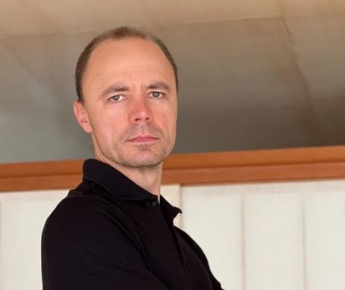

Vasile Ersek is an Associate Professor in the School of Geography and Natural Sciences at Northumbria University, England, specialising in palaeoclimatology and geochemistry. His research focuses on past climate changes and their interactions with the environment and human societies, particularly using natural archives such as cave sediments and peatlands. He is the author of major studies, including the extended history of Asian monsoon variability and the impact of climate change on ancient civilisations. He graduated from Babeș-Bolyai University, completed a master's degree at Mississippi State University and a PhD at Oregon State University, followed by a post-doctoral position at the University of Oxford.
Caves, climate and civilisations: Lessons from the past about the future of water
Vasile Ersek¹
¹ School of Geography and Natural Sciences, Northumbria University, Newcastle, UK vasile.ersek@northumbria.ac.uk

Key words: cave, climate, groundwater, speleothems
Caves are natural laboratories where the atmosphere, soils, rocks, and groundwater meet. This makes them powerful places to observe how water moves today and to read how climate and water changed in the past. In this talk I will show how cave observations and cave deposits (speleothems) together provide "lessons from extremes" that matter for future water security.
Because caves sit in the rocks above the water table, their drip waters respond quickly to rain and snow melt. Tracking when, how fast and how often drips occur, together with measurements of water chemistry and cave air, can reveal when rain becomes groundwater and when it is lost along the way. Caves also let us distinguish slow seepage through pores from rapid flow along fractures—information that is essential for estimating groundwater recharge.
As cave stalagmites grow layer by layer, they lock in the chemical "fingerprints" of the water from which they formed. Radiometric dating techniques allow us to date those layers with precision of decades or centuries. The result is a timeline of past wet and dry periods and of dust and temperature changes. Cave records can provide remarkable archives of rapid climate shifts and their impacts on human societies. For example, stalagmites from Gol-e-Zard Cave in Iran reveal a severe 290-year drought beginning 4,260 years ago—precisely coinciding with the collapse of the world's first empire, Akkadia, in Mesopotamia. This drought transformed fertile agricultural lands into dust-filled wastelands, forcing mass migrations and societal upheaval. Similarly, stalagmites from Tham Doun Mai Cave in Laos document a millennium-long megadrought from 5,100 to 3,500 years ago that may explain Southeast Asia's archaeological "missing millennia"—a period with little evidence of human settlements when populations likely dispersed to find water elsewhere.
Cave archives also illuminate pre-civilisation climate extremes and their effects on early human populations. Stalagmite records from Romanian caves show that Neanderthals faced devastating colddry episodes during the late Ice Age, with temperatures dropping below freezing year-round and creating Arctic-like steppes across central Europe. These climate shifts, lasting centuries, coincided with the disappearance of Neanderthal populations around 40,000 years ago, suggesting our closest human relatives may have been particularly vulnerable to rapid environmental change.
Combining real‑time cave monitoring with well‑dated cave archives helps answer practical questions: How quickly can recharge switch off when storms change character? Which wind patterns and land‑surface feedbacks produce multi‑decadal droughts? Which ecosystems and communities are most exposed when groundwater falters?
Caves offer a vertically integrated, scalable approach to water and climate risk—from detecting present‑day recharge changes to providing long baselines of natural extremes. Lessons from past extremes help us anticipate when rainfall will (and will not) become groundwater in a warming, more variable climate—and support decisions across ecology, microbiology, geoscience, archaeology, and environmental management. Integrating cave climate records with broader paleoenvironmental archives could provide regional climate syntheses. Combining structural geology with cave hydrology could improve groundwater models. Linking cave microbial ecology with paleoclimate chemistry could reveal biogeochemical responses to past extremes. Archaeological site analysis informed by local paleoclimate records could illuminate human adaptation strategies relevant to modern climate planning.
Romania's exceptional cave systems and rich archaeological record position it as an ideal region for developing integrated paleoclimate-archaeological-ecological research programs that inform both scientific understanding and practical climate adaptation.
Angelica Feurdean is a researcher at the Department of Physical Geography, Goethe University Frankfurt am Main, Germany. Her research integrates multidisciplinary analyses (pollen, plant macrofossils, coprophilous spores, charcoal, testate amoebae, stable isotopes, etc.) with models applied to temperate (Europe), boreal (Siberia), and arctic (Alaska) ecosystems. The results provide insights into how climate change and disturbance factors (herbivores, fire, and human activity) influence vegetation structure, diversity, and resilience, fire regimes, hydrological dynamics, and the carbon storage capacity of peatlands. The overarching goal is to deepen the understanding of processes and challenges associated with environmental change, in order to support biodiversity conservation.

Cold-Region Vegetation in a Warmer Past
Angelica Feurdean ¹

¹ Institute of Physical Geography, Goethe University, Altenhöferallee 1, 60438, Frankfurt am Main,
Germany, (feurdean@em.uni-frankfurt.de, angelica.feurdean@gmail.com)

Key words: palaeoecology, pollen, plant macrofossils, charcoal, high-latitude
Long-term ecological research using indirect measurements, or so-called proxies, provides evidence of past ecosystem changes under a range of climatic conditions and disturbance regime pressures. To illustrate this, palaeoecological records of hydroclimate and fire from Arctic tundra and boreal forests in Alaska and Siberia will provide evidence for the direction and magnitude of vegetation and fire regime shifts during warmer periods. This work also emphasis that approaches with a broad temporal and spatial scope make it possible to evaluate complex feedbacks between climate, vegetation, and disturbance, providing a foundation for understanding how these cold regions may respond to ongoing global changes, namely warming, greening, and more frequent fires.

Ion Francovschi is a scientific researcher at the Moldova State University, Institute of Geology and Seismology. He conducts geochemical, paleontological, and geochronological studies on the Ediacaran–Paleozoic volcano-sedimentary succession in the southwestern part of the East European Platform (Baltica), particularly in Moldova, Ukraine, and northeastern Romania, as well as on the geochemistry and geochronology of the Ediacaran–Mesozoic succession in the PreDobrogea Depression (southern Bessarabia). His research interests range from interpreting the origin of phosphorites and distinguishing between alluvial and glacial origins of diamictites, to constraining the age of the Ediacaran fauna and the tectonic evolution of the Ediacaran–Cambrian sedimentary basin.

Accessing the Ediacaran-Cambrian boundary in SW Baltica based on SHRIMP and CA-ID-TIMS zircon U-Pb dates
Ion Francovschi^{1,2}, Maria Ovtcharova³, Mami Takehara⁴, Kevin Chamberlain⁵, Andrey Bekker^{6,7}
- Moldova State University, Institute of Geology and Seismology, Chișinău MD-2009, Moldova, frankovski.ww@gmail.com
- Geological Institute of Romania, Bucharest 012271, Romania
- Department of Earth Sciences, University of Geneva, Switzerland
- National Institute of Polar Research, Tokyo, Japan
- Department of Geology and Geophysics, University of Wyoming, Laramie, USA
- Department of Earth and Planetary Sciences University of California, Riverside, CA 92521, USA ⁷ Department of Geology, University of Johannesburg, Auckland Park 2006, South Africa

Key words: Ediacaran, Cambrian, geochronology
In recent years, using the youngest detrital zircon dates for sedimentary deposits, obtained with the LAICP-MS technique, has become a common method for constraining depositional ages. However, Pb loss from zircons can significantly affect LA-ICP-MS U–Pb zircon dates, potentially resulting in individual zircon U-Pb dates being younger than their crystallization ages.
In the Moldova-Podillya basin, recent U-Pb LA-ICP-MS analyses on zircons from sandstones of the lower Kanyliv Group yielded Maximum Depositional Ages (MDAs) around 523-532 Ma (Paszkowski et al., 2021). These dates conflict with established biostratigraphic evidence (e.g., Ivantsov et al., 2015), which indicates a late Ediacaran age for the Kanyliv Group and places the Ediacaran-Cambrian boundary (defined by the Phycodes pedum ichnofossil zone) above it. The LA-ICP-MS results suggest this boundary should be repositioned below the Kanyliv Group.
To resolve this discrepancy, and considering potential Pb loss, we analyzed zircons from the lowermost Pylypy Beds (Kanyliv Group) near Naslavcea, Moldova. Initially, U-Pb SHRIMP dating of 115 concordant zircons yielded an MDA of 530 ± 10 Ma. This age is younger than the accepted EdiacaranCambrian boundary (538.8 ± 0.2 Ma; Linnemann et al., 2019) and would necessitate reconsidering the Ediacaran-Cambrian boundary placement in southwestern Baltica.
Subsequent chemical abrasion (CA) and isotope dilution–thermal ionization mass spectrometry (IDTIMS) dating of the same youngest zircons revealed a significantly older age of 553.20 ± 0.25 Ma, consistent with the biostratigraphic constraints. These results emphasize the importance of using CAID-TIMS for high-precision chronostratigraphic studies, as Pb loss can cause an apparently younger date than the depositional age of sediments.

Acknowledgements: This research was funded by project PN-III-P1-1.1-PD-2021-0400, No. 60/2022, of the Romanian Executive Agency for Higher Education, Research, Development, and Innovation (UEFISCDI).

References
Ivantsov, A.Yu., Gritsenko, V.P., Paliy, V.M., Velikanov, V.A., Konstantinenko, L.I., Menasova, A.Sh., Fedonkin, M.A., Zakrevskaya, M.A., Serezhnikova, E.A. (2015). Upper Vendian macrofossils of Eastern Europe. Middle Dniester area and Volhynia. Moscow, PIN RAS. 1–144.
Linnemann, U., Ovtcharova, M., Schaltegger, U., Gartner, A., Hautmann, M., Geyer, G., Vickers-Rich, P., Rich, T., Plessen, B., Hofmann, M., Zieger, J., Krause, R. (2019). New high-resolution age data from the EdiacaranCambrian boundary indicate rapid, ecologically driven onset of the Cambrian explosion. Terra Nova 31, 49–58. https://doi.org/10.1111/ter.12368
Paszkowski, M., Budzyń, B., Mazur, S., Sláma, J., Środoń, J., Millar, I.L., Shumlyanskyy, L. (2021). Detrital zircon U-Pb and Hf constraints on provenance and timing of deposition of the Mesoproterozoic to Cambrian sedimentary cover of the East European Craton, part II: Ukraine. Precambrian Research 362, 106282. https://doi.org/10.1016/j.precamres.2021.106282
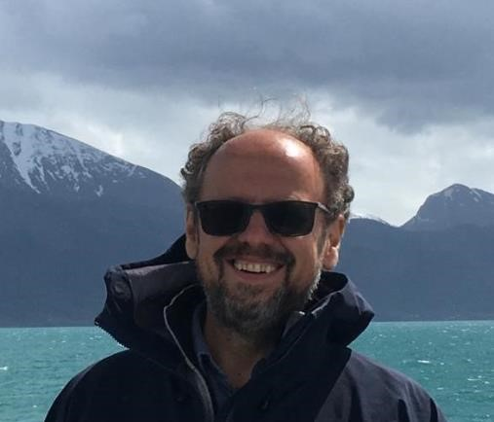
Liviu Giosan, Researcher Emeritus at the Woods Hole Oceanographic Institution, Massachusetts, USA, studies human–climate–landscape interactions and the impact of humans on Earth’s environment. His projects focus on understanding the sources, transport, and transformations of sediments, as well as their climatic, archaeological, and societal significance in both continental and marine settings.

Interdisciplinary frontiers of knowledge: extreme environments from past to future November 4-7, 2025 - Cluj-Napoca

Civilizations as adaptation to environment
Liviu Giosan^{1,2*}
¹ Geology & Geophysics, Woods Hole Oceanographic Institution, USA, lgiosan@whoi.edu ² STAR Institute, Babeș-Bolyai University, Cluj-Napoca, Romania

Key words: earth sciences, cliodynamics, climate, landscapes, complex societies

Interaction between life and abiotic processes make Earth a unique planet. Humans, the top of the food chain, may have reached the stage to influence the planetary processes hundreds if not thousands of years ago. How did this interdependency evolve?
In this talk I will discuss human civilizations as niche adaptations to ephemeral environmental settings and as buffers to extreme events with examples (Fig. 1) from prehistory to modern (e.g., Giosan and Goodman, 2025; Giosan et al. 2012a; Giosan et al., 2012b).

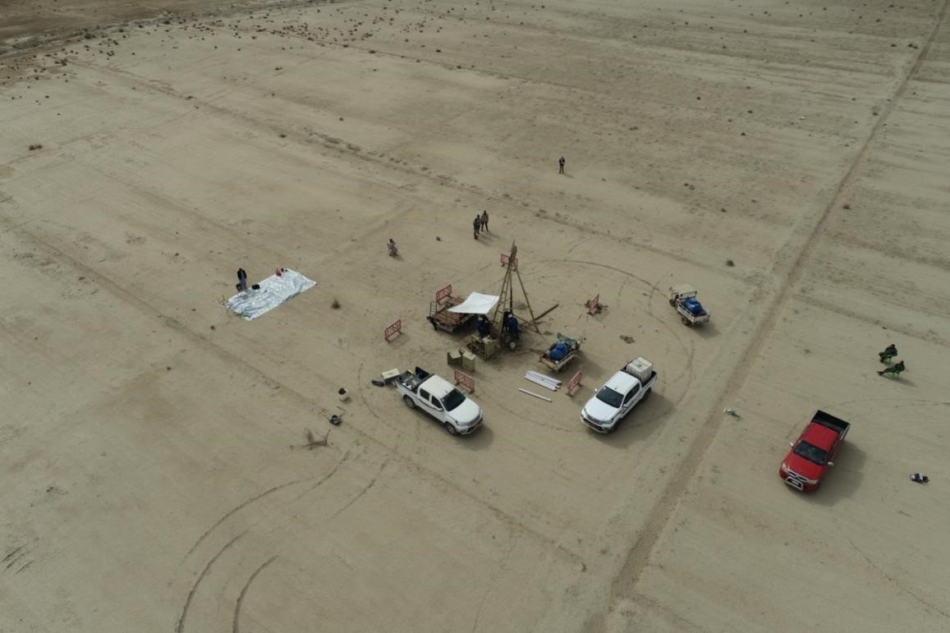

Figure 1. Drone photo of drilling in the Iraqi deserted floodplain of Tigris and Euphrates, once the setting for the first literate, urban human civilization. Copyright: Reed Goodman.

References
Giosan, L. & Goodman, R., 2025. Morphodynamic Foundations of Sumer. PLOS One, 20(8), e0329084.
Giosan, L. & al., 2012a. Fluvial landscapes of the Harappan civilization. PNAS, 109(26), E1688-E1694.
Giosan, L. & al., 2012a. Early anthropogenic transformation of the Danube-Black Sea system. Sci. Reports, 2(1), 582.
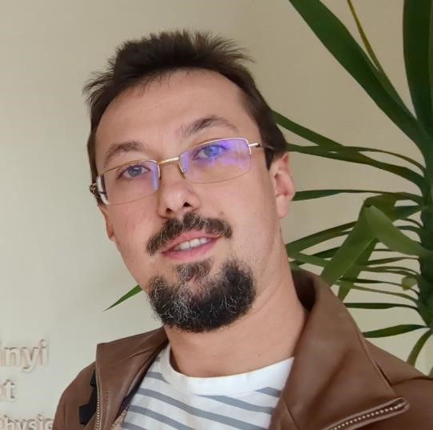
Artur Ionescu is a geochemist specializing in deep carbon processes, gas geochemistry, and natural CO₂ emissions from geothermal and volcanic systems. His research explores the origin, migration, and environmental impact of deep-seated gases in the Carpathian region and other tectonically and volcanic active areas. Using advanced geochemical and isotopic techniques, he investigates pathways of carbon transfer from the Earth’s interior to the surface, contributing to global carbon cycle and climate studies. He has coordinated and participated in numerous international research projects focused on natural Earth degassing, CO₂ flux monitoring, and geochemical tracing of subsurface processes. Actively engaged in academic collaborations and mentoring, Artur Ionescu promotes interdisciplinary research linking geosciences, environmental monitoring, and climate dynamics. His scientific contributions have helped establish the Carpathian Mountains as a natural laboratory for understanding deep carbon emissions and extreme geological environments.
Interdisciplinary frontiers of knowledge: extreme environments from past to future November 4-7, 2025 - Cluj-Napoca

Decoding Deep Carbon Emissions: The Carpathian Mountains as a Natural

Laboratory for Extreme CO₂ Environments
Artur Ionescu^{1*}, Transylvanian Geochemistry Research Group (Jozsef-Szilrad Balo,
Catalin-George Cirje, Iulia-Georgiana Ungur, Anita Bozsik, Luca Bumb, Bogdan
Mihai Cerbu, Ioan Chis, Raluca Andreea Ciur, Miriam Dragomir, Tudor-Stefan
Hilma, Botond Holinka, Elod Komives, Botond-Csanad Kurucz, Andrei Moldoveanu,
Dragos Muntean, Anamaria Muntean-Sarlea, Matei Rogozan, Kamilla Toth, BalazsZoltan Veress)

- Faculty of Environmental Science and Engineering, Babes-Bolyai University, Romania artur.ionescu@ubbcluj.ro
- Department of Physics and Geology, University of Perugia, Italy
- Department of Geology, Faculty of Biology and Geology, Babes-Bolyai University, Romania
- HUN-REN Institute for Nuclear Research (ATOMKI), Debrecen, Hungary
- HUN-REN Institute of Earth Physics and Space Science, Sopron, Hungary ⁶ Doctoral School of Earth Sciences, University of Debrecen, Hungary

Key words: Carpathian Mountains, deep carbon, carbon degassing, mofettic area

The quantification of carbon fluxes between the solid Earth and the atmosphere is crucial for understanding the geological component of the global carbon cycle and its interaction with climate. Deep-seated CO₂ emissions - arising from mantle degassing, metamorphism, and crustal fault systems - represent a significant yet underexplored source of greenhouse gases at a regional and global scale. The Carpathian Mountains, spanning Romania, Slovakia, and Ukraine, provide a unique natural laboratory for investigating such deep carbon processes across diverse tectonic and geothermal settings.
This study presents new results on both present-day and paleo (deep) carbon emissions from mofettic and hydrothermal areas distributed along the Eastern, Slovakian, and Ukrainian segments of the Carpathian chain. Through a combined approach integrating diffuse CO₂ flux measurements, geochemical and isotopic analyses of thermal and mineral waters, and the study of travertine deposits, we assess the intensity and variability of CO₂ degassing over geological times. Travertine formations, interpreted as fossil records of past degassing, offer valuable constraints on the long-term dynamics of deep carbon release and the persistence of mantle-derived signatures in the emitted gases.
Preliminary data indicate that all Carpathian sectors exhibit significant CO₂ outputs, though controlled by differing geological frameworks: the Eastern Carpathians display high fluxes linked to post-volcanic degassing and active faults; the Slovakian sector shows mixed mantle – crustal signatures associated with Neogene volcanic zones; while the Ukrainian Carpathians reveal CO₂ emissions along transcrustal fault systems and in mofettic depressions. Together, these findings support the hypothesis that the Carpathian arc functions as a continuous degassing belt where both tectonic activity and hydrothermal circulation sustain long-term CO₂ release.
Our integrated methodology demonstrates that combining travertine-based paleo flux estimates with present-day CO₂ measurements provides robust constraints on the temporal evolution of deep carbon emissions. The results emphasize the significance of the Carpathians as a major geogenic CO₂ source in Eastern and Central Europe, and as an ideal field analogue for understanding the role of extreme geological environments in the global carbon budget.

Acknowledgements: The start of the research has been funded by the Deep Carbon Observatory (DCO).

Danny Ionescu is a molecular microbial ecologist with research interests ranging from bacterial genome evolution to ecosystem functioning. After moving in September 2024 from the Leibniz Institute of Freshwater Ecology and Inland Fisheries to the Technische Universität Berlin, Germany, his research group focuses on two main directions: giant bacteria—particularly Achromatium, investigating biodiversity, biogeography, and genetic regulation across hundreds of chromosomes—and microbial activity in hypersaline environments, with a special interest in the Dead Sea. His work aims to understand the adaptations that allow microorganisms to survive in extreme environments and to harness these adaptations and enzymes for biotechnological applications.

The Dead sea and its secrets
Danny Ionescu¹, Christian Siebert²,
¹ Department of Environmental Microbiomics, Technische Universität Berlin, ionescu@tu-berlin.de ² Helmholtz-Centre for Environmental Research, UFZ, Germany

(presenting author should be underlined)

Key words: Dead Sea, Halophiles, Underwater springs, Sulfur Bacteria, Halite Chimneys
The Dead Sea is a hypersaline terminal desert lake with a salinity of ca. 350 g L⁻¹ total dissolved salts. Its unique salt composition consisting of high Mg²⁺ (ca. 2M) and Ca²⁺ (0.5 M) renders it inhospitable to most organisms. Nevertheless, despite its name the Lake is not bare of life. Microorgansims have been described in the lake already in the 1930s and its waters harbor ca. 5×10⁴ cells. Before 1979, the lake was stratified and had an anoxic, sulfidic hypolimnion. Following a continuous decrease in water level and increasing salinity in the lakes epilimnion, the lake overturned and is no longer stratified. Since then, the lake is oxygenated to the bottom (300 m).
Traditionally, life in the dead sea has been studies by means of cultivation and rarely through the use of modern molecular tools. Furthermore, as the lake is considered homogenous, samples have been collected in isolated locations believed to represent the entire lake. In my talk I will present results from the last decade (e.g. Ionescu et al., 2012; Siebert et al., 2024) of research on the Dead Sea, suggesting that the biology and ecology of the Dead Sea is more complex.
First, I will present data from underwater freshwater springs in the Dead Sea. These springs are spread in several areas at depth down to at least 35 m, creating oasis of life in their vicinity. could show the formation of photosynthetic biofilms both by oxygenic (Cyanobacteria and diatoms) and anoxygenic (Green sulfur bacteria) phototrophs. We could further measure sulfide oxidation and sulfate reduction in the spring vicinity. Last, we could measure ammonia and nitrite oxidation near the spring, both phenomena that are not expected to occur at high salinities. Characterizing the microbial community in the springs area revealed that all these organisms are present in the Dead Sea and are not brought in by the spring waters.
Second, I will present the first high resolution characterization of dissolved organic matter in the Dead Sea. Here we could show that the Dead Sea harbors >9000 years old refractory organic matter that has been accumulating to concentrations 1000 times higher than in the refractory organic matter pool of the deep oceans. We hypothesize that surface and underwater springs are the main source of the accumulated organic matter.
I will conclude with future perspectives for research in the Dead Sea, including new findings such as fields of halite chimneys, and the possibility of deep springs entering the lake at greater depths, bringing water from, deep, ancient aquifers.

Acknowledgements: This research was partly funded by the Max Planck Society. References:
Ionescu, D., Siebert, C., Polerecky, L., Munwes, Y.Y., Lott, C., Häusler, S., Bižić-Ionescu, M., Quast, C., Peplies, J., Glöckner, F.O., Ramette, A., Rödiger, T., Dittmar, T., Oren, A., Geyer, S., Stärk, H.-J., Sauter, M., Licha, T., Laronne, J.B., de Beer, D., 2012. Microbial and Chemical Characterization of Underwater Fresh Water Springs in the Dead Sea. PLoS ONE 7, e38319–e38319. https://doi.org/10.1371/journal.pone.0038319
Siebert, C., Ionescu, D., Mallast, U., Merchel, S., Merkel, B., Möller, P., Pavetich, S., Pohl, T., Rödiger, T., Yechieli, Y., 2024. A new type of submarine chimneys built of halite. Sci. Total Environ. 955, 176752–176752.
https://doi.org/10.1016/J.SCITOTENV.2024.176752

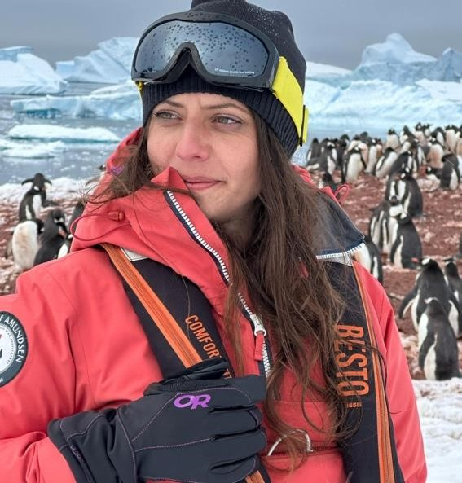
Corina Ițcuș is a researcher in the Department of Microbiology at the Institute of Biology Bucharest of the Romanian Academy, and in the Department of Arctic and Antarctic Research at the National Institute for Research and Development in Biological Sciences, Bucharest.
She is a member of the National Commission for Antarctic and Extreme Environment Research (CNCAME) and of the Underwater and Speleological Exploration Group (GESS). She has participated in eight scientific expeditions - five in Antarctica, and three in Patagonia, Norway, and the Galápagos Islands.
Her research focuses on understanding the impact of climate change on microbial communities in extreme environments, with the aim of identifying climatic biomarkers. Her expertise lies in the structural and functional diversity of extremophilic microorganisms and their applied study through ecological and phylogenetic analyses using genetic and molecular biology methods.
She investigates the genetic diversity and dynamics of environmental microbiomes, with a particular emphasis on aquatic, polar glacial, and alpine environments. Her main studies focus on the regulation of biodiversity and the adaptability of microbial communities to external stress factors, aiming to identify microbial strains of interest for nanotechnology, particularly for potential bionanotechnological applications.

Warming Ice: Climate-Driven Shifts in Microbial Communities of Frozen Ecosystems

Corina Itcus¹, Victoria I. Paun¹, Antonio Mondini¹, Muhammad Z. Anwar², Aurel
Persoiu³, Carsten S. Jacobsen², Cristina Purcarea¹

- Institute of Biology Bucharest, Romanian Academy, Splaiul Independentei 296, 060031 Bucharest, Romania, cristina.purcarea@ibiol.ro
- Aarhus University RISØ Campus, Frederiksborgvej 399, 4000 Roskilde, Denmark
- “Emil Racoviță” Institute of Speleology, Romanian Academy, Clinicilor 5, 400535 Cluj-Napoca, Romania

Key words: ice microbiome, heat-shock, Scarisoara ice cave, meta-omics

Investigation of the temperature dependence of ice microbiomes reveals distinct patterns in both community structure and molecular responses to climate variability. Focusing on glacial habitats, specifically the perennial ice deposits of Scarisoara Ice Cave (Romania) which act as natural paleoclimate archives, we examined the long-term effects of climate fluctuations over the past 13,000 years on total and active prokaryotic and eukaryotic communities preserved in underground ice based on Illumina 16S rRNA/ITS2 gene sequencing of gDNA and rDNA, rRNA shotgun sequencing, and mRNA metatranscriptomic profiling.
Variations in microbial profiles, shaped by depositional and post-depositional geochemical processes, highlighted the substantial influence of climate shifts on microbial abundance, community structure, and even the drug resistance responses of bacterial strains isolated from millennia-old ice. Heat-shock simulations of 900-year-old ice microbiomes, mimicking glacier melting, demonstrated selective shortterm enrichment of resilient bacterial and fungal taxa, as well as diverse microeukaryotes.
At the genetic level, temperature cycling induced upregulation of genes related to enzyme recovery, energy storage, carbon and nitrogen metabolism, and cell motility. Molecular adaptations included enzymes supporting DNA synthesis, posttranslational modifications, defense mechanisms, and stabilizer synthesis.
These findings shed light on the functional resilience and adaptive strategies of microorganisms in glacial ecosystems, offering insights into their potential responses to thermal variations under ongoing climate change.

Acknowledgements: This research was funded by the European Union’s H2020 Research and Innovation ITN programme under the Marie Skłodowska-Curie grant agreement No. 675546, and by the Romanian Academy project RO1567‑IBB05/2024

References
- Mondini, A., Anwar, M.H., Ellegaard-Jensen, L., Lavin, P., Jacobsen, C.S., Purcarea, C. (2022) Heat shock response of the active microbiome from perennial cave ice. Front. Microbiol. 12:809076 DOI: 10.3389/fmicb.2021.809076
- Paun, V.I., Lavin, P., Chifiriuc, M.C., Purcarea, C. (2021) First report on antibiotic resistance and antimicrobial activity of bacterial isolates from 13,000-year old cave ice core. Sci Rep . 11, 514. DOI: 10.1038/s41598-02079754-5
Liviu Matenco holds a degree in Geological Engineering (1991). He taught at the Faculty of Geology and Geophysics of the University of Bucharest until 2003, reaching the rank of Associate Professor, and earned his PhD in Tectonics at VU University Amsterdam (1997). He served as a researcher and research leader at the Royal Netherlands Academy of Arts and Sciences (2003–2011), became an Associate Professor at VU Amsterdam in 2011, and since 2017 has been Professor of Tectonics and Sedimentary Basins at Utrecht University, the Netherlands. In parallel, he collaborates with the University of Bucharest, where he has been a member of the Doctoral School of Geology since 2021. His research focuses on tectonics, basin evolution, and lithospheric dynamics, with applications in Europe and other regions of the world, contributing to a better understanding of the evolution of the Carpathians.

The framework of the deep-time extreme changes and events Liviu Matenco¹
¹ Utrecht University, Department of Earth Sciences, The Netherlands, l.c.matenco@uu.nl

Key words: tectonics, sedimentation, climate, deep-time

The deep-time evolution of orogenic systems and coupled sedimentary basins has shown rapid changes at the recent geological time-scale forcing the evolution of mountain chains and sediments distribution, which are particularly important for Central-Eastern European systems, such as the Carpathians-Dinarides. The evolution of gateways connecting sedimentary basins shown moments of rapid inward or outward sedimentary shifts characterized by a sudden increase with one order of magnitude of sediment delivery, conditioned by tectonics and climate. Changes in climate, such as during the Middle Miocene Climatic Optimum, have strong feedbacks with the orogenic evolution and conditions the rapid and short-lived development of intra-mountainous lakes and tectonic switches, whose effects are poorly understood. The more recent evolution of the Carpathians induces extreme changes in the landscape evolution, resulting in significant environmental hazards and acceleration of extreme events. The multi-scale research across multiple couplings between orogenic areas and sedimentary basin systems demonstrate the need of multi-disciplinarity in the process-oriented understanding of deep-time changes and deriving the long-term geological forcing of extreme events and environments.

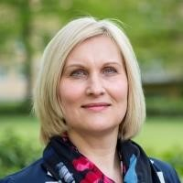
Niculina Mușat is one of the pioneers in applying chemical imaging techniques at the single-cell level in environmental microbiology, combining phylogenetic identification with metabolic activity analysis through state-of-the-art imaging technologies and isotopic labeling. She earned her bachelor’s and master’s degrees in biology from the University of Bucharest and obtained her PhD in 2006 at the Max Planck Institute for Marine Microbiology and the University of Bremen. She led the nanoSIMS platform at the Max Planck Institute and later the ProVIS Center (Helmholtz UFZ, Leipzig), developing high-resolution chemical imaging methods for studying cellular metabolism and its role in biogeochemical processes. Since 2023, she has been working at Aarhus University, Denmark, focusing on microbial metabolic interactions in anoxic environments.

Revealing hindered physiological traits in environmental microorganisms by isotope probing and advanced imaging technologies

Niculina Mușat¹

¹ Department of Biology, Section for Microbiology, Aarhus University, Ny Munkegade 116, DK-8000, Aarhus C, Denmark, niculina.musat@bio.au.dk

Key words: fluorescence in situ hybridization, isotope tracers, high-resolution mass spectrometry, microbial communities

Microbes are the hidden engines of life on Earth: they drive the cycles of carbon, nitrogen, metals, and other elements that sustain ecosystems. Yet studying what they do in their natural environments down to single species or individual cells is challenging. Microbial communities often contain thousands of different species, many of which cannot be grown in the laboratory using traditional cultivation methods. The advent of single-cell chemical imaging has revolutionized microbial ecology research. Known as SIP-FISH-nanoSIMS, the use of isotope tracers (SIP) in combination with fluorescence in situ hybridization (FISH) and high-resolution mass spectrometry (nanoSIMS) can boast remarkable sensitivity, enable tracing and quantification of cellular anabolic activities. Widespread application of this combinatory approach in microbial ecology has yielded significant insights into metabolic interactions among uncultured microorganisms of unknown physiology. Particularly in the intricate spatial and trophic relationships of biological systems where nutrient exchange occurs rapidly. SIP-FISH-nanoSIMS transcends conventional methods, addressing a spectrum of questions from microbe-host and microbe-microbe interactions to single-cell ecophysiology and cellcell nutrient or metabolite exchanges, including interactions with the surrounding organic/inorganic environment. This presentation will showcase selected examples alongside complementary imaging techniques underscoring the versatility and efficacy of this single-cell approach to solve hindered functional traits in environmental microorganisms.

Magdalena Năpăruş-Aljančič is a geographer and reserch associate at the Karst Research Institute ZRC SAZU, where she works with data management and GIS modeling (LiDAR, geo- and biodiversity, habitat suitability and conservation of endangered cave fauna). She actively participates in working groups for the European research infrastructures LifeWatch ERIC, EPOS ERIC and eLTER ESFRI. Since 2009, she has been collaborating at the Tular Cave Laboratory in research and conservation of the endangered olm (Proteus anguinus).
Mapping extremes in karst: databases, portals and research infrastructures
Magdalena Năpăruş-Aljančič ^{*1, 2}, Žan Kafol^{1,3}, Stanka Šebela¹, Tanja Pipan¹
¹ Karst Research Institute ZRC SAZU, Postojna Slovenia, magdalena.aljancicr@zrc-sazu.si ² Tular Institute, Kranj, Slovenia,³ KAFOL.NET, Slovenia

Key words: karst database, metadata portal, LTER Slovenia, EPOS Slovenia, LifeWatch Slovenia

The recently established Data Center at the Karst Research Institute ZRC SAZU is developing digital environments designed to advance multidisciplinary research of karst systems by interlinking diverse datasets, tools, research sites, and scientific communities. A cornerstone of this effort is the IZRK Metadata Portal (https://metadata.izrk.zrc-sazu.si), built on the GeoNetwork platform. The portal enables standardized cataloguing of environmental datasets, research equipment, and workflows, while also ensuring secure data storage and adherence to FAIR principles. By connecting to major international research infrastructures such as LifeWatch ERIC, EPOS ERIC, and eLTER RI, the portal provides a bridge between local and global initiatives, thereby strengthening the visibility and reusability of Slovenian karst research.
Complementing this, the Slovenian Karst Database (KarstDB; https://karstdb.zrc-sazu.si) has been launched as a prototype platform for structuring, storing, and visualizing both raw and processed karstological data. Its architecture integrates multiple services: GeoNetwork for metadata management, QGIS Server for raster datasets, ArcGIS Online for vector layers, specialized environments for interactive data visualization, and a Handle PID system for persistent identifiers. This technological neutrality and interoperability make KarstDB a flexible, collaborative infrastructure that promotes data sharing across disciplines and supports long-term accessibility.
Together, these two initiatives demonstrate how the integration of heterogeneous data sources and services can facilitate the mapping of karst extremes, enhance interdisciplinary collaboration, and reinforce research infrastructures that benefit both national and international stakeholders.

Acknowledgements: This research is funded by ARIS (Slovenian Research and Innovation Agency) programmes Karst Research (P6-0119) and several EU projects are also acknowledged: eLTER Preparatory Phase Project (eLTER PPP); eLTER Advanced Community Project (eLTER PLUS); LifeWatch & eLTER (I0-E016); »Development of research infrastructure for the international competitiveness of the Slovenian RRI space—RI-SI-LifeWatch« and LifeWatch ERIC; EPOS (I0-E017); HE projects: EPOS ON (101131592) and TRANSFORM² (101188365); and »Development of research infrastructure for the international competitiveness of the Slovenian RRI space—RI-SI-EPOS«.

Laurențiu Nicolae is an aerospace engineer with 9 years of experience, the last 5 of which have been with the European Space Agency. He works as a systems engineer in the Moon exploration department, working on a multitude of specific projects, ranging from scientific equipment for the lunar surface to technology demonstrators and Moon landing systems.
The Lunar Environment – A Proving Ground for Space Technologies, Laurenţiu Nicolae¹
¹ European Space Agency (ESA), Noordwijk, The Netherlands, laurentiu.nicolae@esa.int

Key words: Luna, lunar environment, space technologies
The lunar environment is among the most hostile and unforgiving in the entire Solar System. Defined by the near-total absence of an atmosphere and by extreme temperature swings, it has profoundly shaped both the morphology and the internal structure of Earth’s natural satellite. These conditions make the Moon a unique scientific laboratory—an ideal site for unravelling the processes of planetary formation and for preparing future strategies of space exploration and colonization.
Unlike Earth, the Moon has no true atmosphere—only an extremely thin, unstable exosphere. Without natural protection, its surface is subjected to unceasing bombardment from ultraviolet solar radiation, high-energy cosmic particles, and micrometeoroids that strike at full velocity in the absence of atmospheric drag. As a result, any structure or system placed on the lunar surface must endure conditions comparable to deep space, further complicated by the Moon’s local extremes.
Temperature is one of the most daunting challenges. With no atmospheric convection, heat cannot redistribute, producing dramatic variations. Sunlit regions can exceed +120 °C, while permanently shadowed craters near the poles or areas on the far side can plunge below –170 °C. To cope, future missions require advanced materials and thermal-control systems capable of balancing between overheating and extreme cold, especially during the two-week-long lunar night.
Reduced gravity presents another fundamental constraint. At just one-sixth of Earth’s gravity, the lunar environment directly affects the design of vehicles, robots, and habitats. Stability, mobility, and even human biomechanics differ significantly from terrestrial conditions, demanding innovative engineering solutions.
Equally problematic is the lunar regolith: a blanket of fine, abrasive, and electrostatically charged dust that coats the entire surface. Formed over billions of years by constant meteoritic impacts, these sharpedged particles can quickly erode filters, seals, and mechanical joints. They cling stubbornly to spacesuits and equipment, infiltrating habitats where they threaten both human health and sensitive electronics.
The lunar day-night cycle further compounds these challenges. A single lunar day lasts roughly 14 Earth days, followed by an equally long night. Solar-powered systems cannot function without sophisticated energy storage and backup technologies—ranging from high-capacity batteries and compact nuclear reactors to hybrid systems capable of providing continuous power.
Taken together, these factors make the Moon not merely a destination, but a proving ground. It offers unparalleled opportunities to test human adaptability, to develop technologies for survival in extreme conditions, and to prepare for the next great leap in exploration—sustained missions to Mars and, ultimately, beyond.
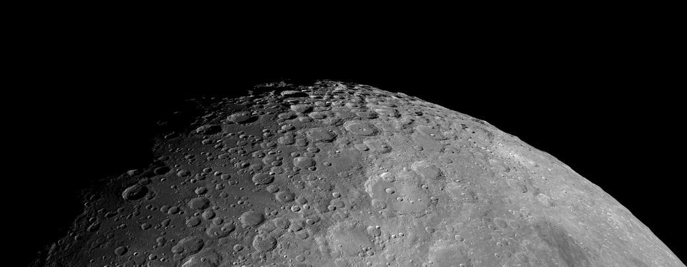
Figure 1. The surface of the Moon as seen from orbit. Copyright: ESA.
Andreea Niță is a researcher in the field of sustainability, impact assessment, and adaptation to climate change, with experience in environmental quality analysis and complex networks. She has received prestigious scholarships, such as SCIEX (EPFL, 2012–2013) and Fulbright (Ohio State University, 2019), and since 2015 has been working at the Center for Environmental Research and Impact Studies (University of Bucharest). She is currently a Marie Skłodowska-Curie postdoctoral researcher at the University of Granada, Spain, and president of the climate change section of IAIA (International Association for Impact Assessment). Her areas of interest include sustainability, impact assessment, climate change adaptation, and the integration of innovation into environmental management.

Environmental assessment in complex networks for the integration of European policies addressing extreme environment challenges
Andreea Nita^{1*,} Montserrat Zamorano¹
¹ University of Granada, Department of Civil Engineering, andreea.nita@ugr.es

Key words: network, climate change, brokers, EU policies, integration, sustainability
Environmental policies implementation through different procedures such as Environmental Impact Assessment (EIA) form the foundation of European environmental governance. However, in practice, these instruments mostly fail to capture the systemic and interdependent quality of policies implementation tackling climate change and extreme environmental conditions. We envisage a network-based approach within the context of evolving and present EU environmental policies, including the European Green Deal, the Fit for 55 package, and the Circular Economy Action Plan. Through the application of complex network analysis, this research investigates the key climate and environmental policy instruments of the EU to identify central nodes and brokers that are contributing to coordination and collaboration across environmental, industrial, and civic governance systems. In addition, indicators such as reducing greenhouse gas emissions, improving energy efficiency, and protecting biodiversity emerge as important multifaceted connectors across situated policies and the environmental policy network. According to the betweenness and eigenvector centrality values, the European Green Deal and EU ETS stand out as anchor policies, and through their position they are bridging otherwise fragmented clusters. Using K-core clustering, institutional actors emerge as key brokers to the implementation of policies and are the brokers - particularly the European Commission and national governments - situated to mediate across regulatory, industrial, and civic stakeholders. We demonstrate that embedding EIA into the multilayered policy networks will enable it to account for cumulative impacts, prepare for extreme risks, and operationalize the whole of government perspective. The network perspective followed in NetDeal Project is ultimately relevant in improving extreme environments governance, where climate stressors, declining biodiversity, and socio-economic inequalities and vulnerabilities demand the use of important tools that are strong, adaptive and respond to current environmental issues. By addressing systems change, the framework connects important processes such as EIA procedure not solely as a compliance exercise, but proactively as an integrator of EU sustainability objectives, building resilience and informed decision-making under environmental uncertainty.
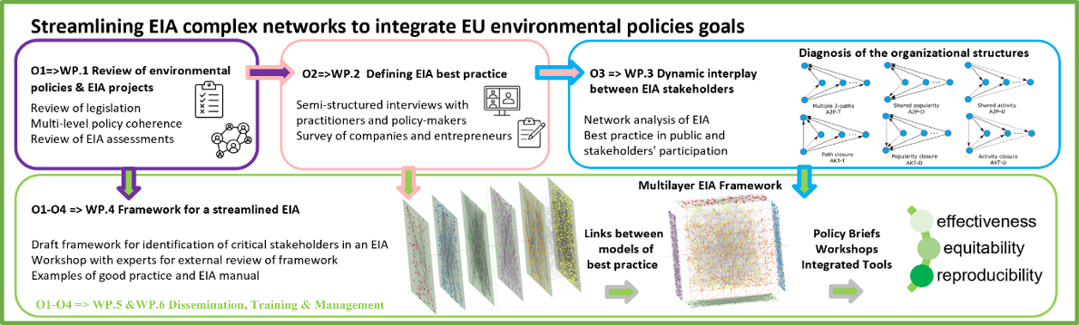
Figure 1. The research objectives of the NetDeal project and the methodological design

Acknowledgements: Funded by the European Union. We acknowledge the financial support of the Marie Sklodowska-Curie Actions (MSCA) Individual Fellowship under grant agreement No 101152528.

References Nita, A., Zamorano, M., Rozylowicz, L. (2025). Exploring legal frameworks for climate action: a network analysis of Green Deal, EU Directives, and environmental assessment indicators. J. Phys.: Conf. Ser. European Commission (2020). The European Green Deal. Brussels: EC Communication. Newman, M. E. J. (2010). Networks: An Introduction. Oxford University Press.
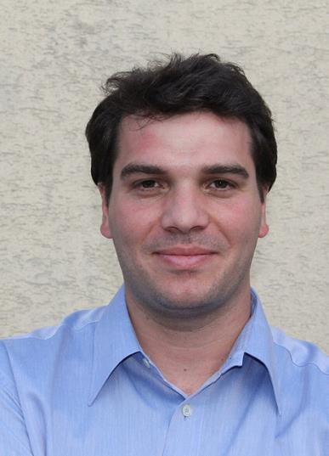

Ovidiu Păun graduated from the Faculty of Agronomy in Bucharest, Romania in 2000 and obtained his PhD from the University of Vienna, Austria, in 2005. After a postdoctoral period at the Royal Botanic Gardens, Kew, United Kingdom, he returned in 2010 to the University of Vienna, where he is currently a tenured Associate Professor and heads the Plant Ecological Genomics Lab. He has received several prestigious awards and research grants, including a Marie Skłodowska-Curie Fellowship, an Erwin Schrödinger Fellowship, and the highly competitive START Prize awarded in 2013 by the Austrian Science Fund (FWF). Păun’s research focuses on the evolution and mechanisms of plant adaptation to extreme environments, including metal-rich soils, drought, high altitudes, and climate change.

Resilience at the extremes: epigenetic responses of high-alpine plants to a warming world
Florian Brück¹, Kryštof Chytrý¹, Norbert Helm¹, Conchita Alonso², Claude Becker³,
Karl Hülber¹, Stefan Dullinger¹, Ovidiu Paun¹
¹Department of Botany and Biodiversity Research, University of Vienna, 1030 Vienna, Austria, ovidiu.paun@univie.ac.at
²Estación Biológica de Doñana, Consejo Superior de Investigaciones Científicas, 41092 Sevilla, Spain
³LMU Biocenter, Faculty of Biology, Ludwig-Maximilians-University Munich, Martinsried, Germany Key words: alpine plants, climate change, DNA methylation, epigenetics, gene expression.
Alpine ecosystems contain exceptional biodiversity and endemism despite covering only a small fraction of Earth’s surface. Their extreme ecological specialization and restricted habitat space make high-alpine species particularly vulnerable to climate warming. Rising temperatures impose physiological stress and intensify competition from lower-elevation species migrating upwards, while suitable alpine habitats diminish. Consequently, high-alpine species risk becoming trapped on shrinking cold “islands”, ultimately leading to mountaintop extinctions. Whether alpine plants can persist depends on their capacity to adjust to rapid environmental change. Classical adaptation through genetic evolution may be too slow, whereas short-term mechanisms of phenotypic plasticity—such as epigenetic regulation of gene expression—might buffer environmental stress. However, the role of such mechanisms in natural settings remains poorly understood.
Using long-term transplantation experiments along altitudinal gradients, we investigated molecular responses to simulated warming in unrelated alpine plant species. The experimental design exposed plants to a sustained ~2.5°C increase over four growing seasons under field conditions, allowing us to capture molecular, physiological, and survival responses under realistic ecological conditions. Significant gene expression differences were detected between control and warmed transplants in all species. Enrichment analyses revealed an overrepresentation of stress-response functions, particularly those associated with heat and oxidative stress, which showed increased expression under warming. Species-specific patterns were also evident: for instance, Sibbaldia procumbens displayed signatures of drought stress consistent with drier conditions, while Veronica alpina exhibited gene expression linked to altered light and radiation exposure. These results show that experimental warming triggers coherent and biologically meaningful molecular responses aligned with expected environmental pressures.
Complementary analyses of DNA methylation confirmed consistent and robust temperature-dependent shifts across species. Global methylation levels increased under warming, driven mainly by significant rises in CHH methylation within non-coding regions, including transposable elements and promoters. Thousands of differentially methylated regions were identified, mostly in non-coding sequences, suggesting genome-wide regulatory adjustments. The limited overlap between methylation and expression changes suggests that many transcriptional responses are not directly mediated by local methylation differences. Instead, the genome-wide methylation increase likely reflects efforts to maintain genome stability under stress, especially by repressing transposable element activity—an important protective mechanism under environmental stress that may also generate variation relevant for future adaptation.
Together, these findings reveal that high-alpine plants exhibit coordinated epigenetic and transcriptional responses to climate warming, consistent with both general and species-specific stress pathways. The results highlight the potential—but also the limits—of epigenetic plasticity as a short-term buffering mechanism. Integrating these molecular insights with ecological monitoring will improve our understanding of the resilience of alpine biota and inform conservation strategies for species at risk in rapidly changing mountain ecosystems.
Acknowledgements: This research is funded by the Austrian Climate Research Program under the Austrian Climate Research Programme.
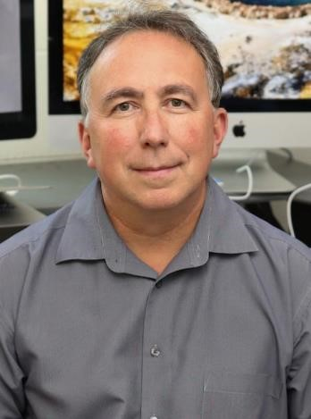
Mircea Podar has been a distinguished scientist at the Oak Ridge National Laboratory in Oak Ridge, Tennessee, United States, since 2007, and an associate professor of microbiology at the University of Tennessee, Knoxville, United States. A graduate of the Faculty of Biology at “Babeș-Bolyai” University in Cluj-Napoca (1988), he earned his PhD in biomedical sciences at the University of Texas Southwestern Medical Center in Dallas, Texas (1997). He subsequently conducted postdoctoral studies at the Woods Hole Oceanographic Institution (WHOI), Massachusetts, and at the Salk Institute for Biological Studies in La Jolla, California.
His research focuses on microbial communities associated with the human body, plants, extreme geothermal and marine environments, as well as other ecosystems. His studies concentrate on genomics, metagenomics, cultivation of new microbial species, and microbiological applications in medical and biotechnological fields.

Exploring Microbial Frontiers through Genomics and Metagenomics – From the Human Ecosystem to the Extremes of Life Mircea Podar
Oak Ridge National Laboratory and The University of Tennessee, USA podarm@ornl.gov

Key words: metagenomics, microbes, human microbiome, extremophiles
A substantial fraction of microbial diversity—including entire high-level lineages—remains uncultured, limiting our ability to study their biology and ecological roles. Although cultivation-independent genomic approaches provide valuable hypotheses about how these microbes function within communities, direct cultivation is essential to experimentally characterize their physiology and interactions. Traditional methods, which rely on selective media or brute-force high-throughput screening, rarely succeed in isolating specific uncultured taxa.
To overcome this barrier, we developed targeted approaches that leverage single-cell and metagenomic information to identify, isolate, and culture selected microbes from complex environments such as hot springs, sulfidic sediments, and the human microbiome. Our strategy employs antibodies engineered against predicted membrane proteins, enabling recovery of target cells via flow cytometry– based sorting. Using this method, we successfully cultivated multiple symbiotic lineages, including Nanoarchaea, Saccharibacteria (TM7), and Gracilibacteria (SR1/GN02). Because many uncultured Bacteria and Archaea are predicted to depend on direct interactions with partner organisms, culturebased isolation remains the only way to confirm and dissect these associations. The reverse-genomics framework enables the selective cultivation of novel bacterial and archaeal lineages—both symbiotic and free-living—thereby opening new avenues for understanding microbial diversity across ecosystems and host-associated microbiomes.
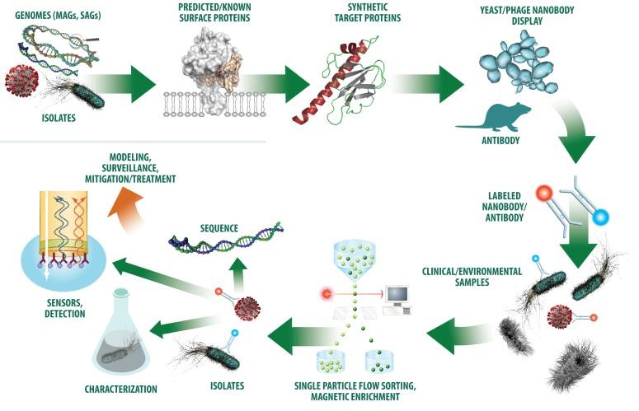
Figure 1. Diagram for microbial isolation and characterization through Targeted Reverse Genomics.
Acknowledgements: This research has been funded by grants from the U.S. Department of Energy, National Science Foundation, NIH and NASA.

References
Cross KL, Campbell JH, Balachandran M, Campbell AG, Cooper CJ, Griffen A, Heaton M, Joshi S, Klingeman D, Leys E, Yang Z, Parks JM, Podar M. (2019) Targeted isolation and cultivation of uncultivated bacteria by reverse genomics. Nature Biotechnology, 37(11):1314-1321.
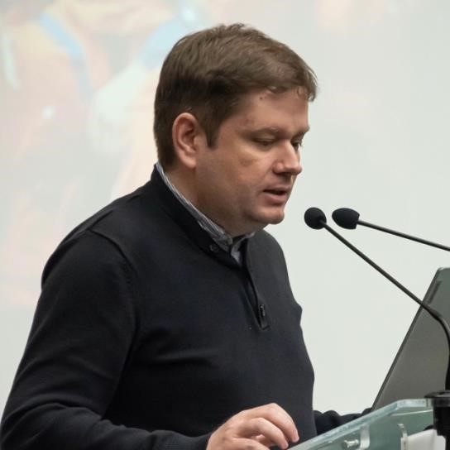
Claudiu Tănăselia is a scientific researcher at INCDO INOE 2000, Institute for Research in Analytical Instrumentation (ICIA), Cluj-Napoca. He has over 15 years of experience in inductively coupled plasma mass spectrometry (ICP-MS) and X-ray fluorescence (XRF), analytical techniques applied to environmental sample analysis as well as to transdisciplinary fields such as heritage and cultural identity. With a strong interest in space sciences, he has developed and applied ICP-MS methods for quantitative determinations of heavy metals, rare earth elements, and lead isotopic ratio measurements in meteorites.

Analytical investigations on the Romanian meteorites Mocs and Pleșcoi
Claudiu Tănăselia^{1*}, Iulia Török¹, Oana Cadar¹
¹ INCDO INOE 2000 Research Institute for Analytical Instrumentation (ICIA) Cluj-Napoca claudiu.tanaselia@icia.ro

Key words: chondrite, meteorite, ICP-MS, REE, isotopic ratios
Mocs is the largest Romanian meteorite identified to date (out of a total of 11, according to Meteoritical Bulletin), with a mass exceeding 300 kg. It fell in 1882 near Mocs village, less than 50 km from ClujNapoca. Pleșcoi, the most recent observed fall in Romania (2008), has a main mass of 6.91 kg. Both Mocs and Pleșcoi are chondrites, a class of meteorites that make up more than 80% of all meteorites recovered on Earth. The elemental composition, including rare-earth elements (REE), was analyzed in both meteorites using inductively coupled plasma mass spectrometry (ICP-MS), combined with laser ablation (LA-ICP-MS) for direct bulk measurements on solid samples. Lead (Pb) isotopic ratios were also determined using a triple-quad ICP-MS instrument. All results were consistent with previously reported data for other chondrites. Samples were kindly provided by the Mineralogy Museum of BabeșBolyai University, Cluj-Napoca.

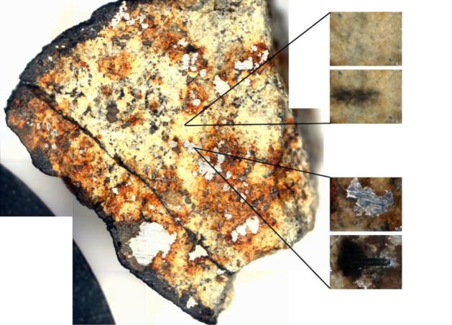
Figure 1. Section of a Mocs meteorite fragment, showing areas analyzed by laser ablation inductively coupled plasma mass spectrometry (LA-ICP-MS)

Acknowledgements: This research was funded by Development of methods for measuring isotopic ratios for dating and other geological applications, using high-resolution mass spectrometry (HR-ICPMS) coupled with a laser ablation system, project UBB/RICI POSDRU/159/1.5/S/132400 and Core Program within the National Research Development and Innovation Plan 2022-2027, carried out with the support of MCID, project PN-23-05

References
C. Tănăselia, S. Ilić-Popov, D. Pop, B. Abraham, C. Roman, T. Stafilov, L. David, Preliminary Investigation of Mocs
Meteorite by Lead Isotopic Ratio using Quadrupole Inductively Coupled Plasma Mass Spectrometry, Studia Universitatis Babeș-Bolyai Chemia 55 (2010): 191-196;
C. Tănăselia, M. Miclean, C. Roman, D. Pop, An assessment of rare earth elements composition of Romanian meteoritic material using an inductively coupled plasma mass spectrometry method, Studia Universitatis BabeșBolyai Chemia 57 (2012): 145-149;
C. Tănăselia, O. Cadar, M. Câmpeanu, C. Balica, T. Dippong, Revised rare earth elements composition of Mocs meteorite using HR-ICP-MS and ICP-QMS analysis, Studia Universitatis Babeș-Bolyai Chemia, 61 (2016): 401406;
Pavel Dan Turtureanu has an active research activity mainly in alpine ecology. He is particularly interested in addressing questions related to thermal conditions experiences by high-elevation species and communities, dynamics of alpine grasslands under global changes and functional ecology of plants. He is primarily focused on alpine herbaceous ecosystems of the Carpathians and operates a longterm network of soil temperature monitoring sites across the region. He is also involved in high elevation flora international monitoring initiatives such as the Global Observation Research Initiative in Alpine Environments aimed at documenting the effects of climate change on the vulnerable alpine flora worldwide.
Shrub expansion as a key driver of mountain greening in the Carpathians
Pavel Dan Turtureanu^{1,2,3,4}, Arthur Bayle^{5,6,7}, Baptiste Nicoud⁷, Mihai Pușcaș^{1,2,3,4}, Philippe Choler⁷
¹Borza Botanic Garden, Babeș-Bolyai University, 42 Republicii Street, 400015 Cluj-Napoca,
Romania, pavel.turtureanu@ubbcluj.ro
²Faculty of Biology and Geology, Babeș-Bolyai University, 44 Republicii Street, 400015 Cluj-Napoca, Romania
³Centre for Systems Biology, Biodiversity and Bioresources (3B), Babeș-Bolyai University, 3-5
Clinicilor Street, 400006 Cluj-Napoca, Romania
⁴Emil G. Racoviță Institute, Babeș-Bolyai University, 5-7 Clinicilor Street, 400006 Cluj-Napoca,
Romania
⁵Climate Change Impacts and Risks in the Anthropocene (C-CIA), Institute for Environmental Sciences, University of Geneva, 66 Boulevard Carl Vogt, CH-1205 Geneva, Switzerland
⁶Department F.-A. Forel for Environmental and Aquatic Sciences, University of Geneva, 66 Boulevard
Carl Vogt, CH-1205 Geneva, Switzerland
⁷University Grenoble Alpes, University Savoie Mont Blanc, CNRS, LECA, F-38000 Grenoble, France

Key words: Carpathians, greening, mountains, remote sensing
In recent decades, cold regions of the world have become increasingly green, and shrub expansion is one of the key processes driving this change. However, we still know relatively little about these transformations in the mountains of Eastern Europe, where land-use practices changed substantially after the fall of communism. Until now, the role of shrubs has been little studied, mainly because producing detailed maps of their distribution is challenging. In our research, we used four decades of Landsat satellite imagery, combined with a vegetation type classification based on Sentinel-2 images, to analyze greening dynamics above 1500 m elevation in the Carpathians. The classification focused on the main shrub types. We also examined aerial photographs from different time periods, including satellite images from the Cold War era, to assess long-term vegetation change. Our results show that 44% of the studied area experienced greening, especially at mid-elevations (1800–2300 m) and on north-facing slopes. Detailed maps indicate that ericaceous shrubs (family Ericaceae) and juniper (Juniperus communis var. saxatilis) contributed most to this greening. Historical photographs confirm that woody vegetation has expanded in these areas. We concluded that the decline of traditional landuse practices, particularly intensive grazing, has been a major factor enabling the resurgence of subalpine shrubs, once much more widespread. Our study highlights the importance of combining highresolution satellite imagery with historical aerial photography to better understand the complex process of greening in mountain ecosystems.
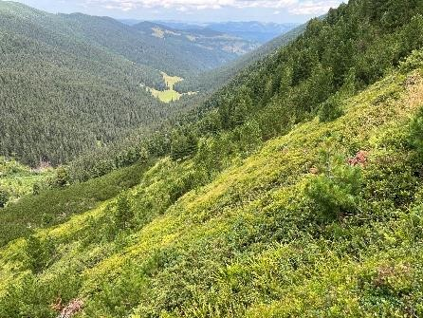
Figure 1. Slope dominated by ericaceous shrubland in the Eastern Carpathians (Rodna Mountains).

Acknowledgements: This research was supported by the GreenMount project (PN-IV-P2-2.1-TE2023-0726), funded by UEFISCDI Romania, and by the MUGO project (34073/16.08.2023), funded by the Agence Universitaire de la Francophonie, Babeș-Bolyai University of Cluj-Napoca, and CNRS France.

References
Turtureanu, P. D. D., Bayle, A., Nicoud, B., Pușcaș, M., & Choler, P. (2025). Landscape-scale analysis of shrub encroachment unveils the complexity of greening in the Carpathian Mountains. Environmental Research Letters.
DOI: https://doi.org/10.1088/1748-9326/ae05b2
Lorena Cristina Văcar is a biologist at Babeș-Bolyai University (UBB) and is affiliated with the Centre for Systems Biology, Biodiversity and Bioresources (3B). She is part of the Plant Tolerance to Environmental Stress Biology Group, led by Assoc. Prof. Dorina Podar, where she contributes to research on the molecular mechanisms involved in metal resistance in plants and fungi. Her work focuses on heavy-metalresistant micromycetes, investigating processes of biosorption, bioaccumulation, and detoxification, as well as their interactions with plants. By integrating studies of physiology, molecular biology, and microbial ecology, her research supports the development of phytoremediation strategies and the use of microorganisms and plants in the remediation of soils contaminated with heavy metals.

From pollution to solution: the study of heavy metal-resistant fungi for bioremediation
Cristina Lorena Văcar¹, Dana Emanuela Tiodar¹, Dorina Podar^{1, 2,*}
- Centre for Systems Biology, Biodiversity and Bioresources (3B), Babeș -Bolyai University, 3-5 Clinicilor St., 400015 Cluj-Napoca, Romania, dorina.podar@ubbcluj.ro
- Department of Molecular Biology and Biotechnology, Babeș-Bolyai University, 1 Kogălniceanu St., 400084 Cluj-Napoca, Romania

Key words: micromycetes, heavy metals, mercury, mycoremediation, resistance mechanisms
Soils impacted by mining and industrial activities are often polluted with hazardous concentrations of heavy metals, with Hg being among the most persistent and toxic due to its mobility, tendency to bioaccumulate, and long-term ecological risks. Nature-based solutions represent a sustainable, economical, and restorative alternative to conventional remediation techniques. Our group focuses on advancing microorganisms-assisted phytoremediation, which employs plants adapted to survive under high contaminant stress in cooperation with resistant bacteria and microscopic fungi. These microorganisms can facilitate plant survival by producing growth-promoting compounds and/or reduce metal toxicity or availability through biosorption, bioaccumulation, or biovolatilization within the rhizosphere. The integrated potential of the bacteria–fungi–plant triad remains largely unexplored. Focusing on indigenous, site-adapted organisms is essential to harness naturally evolved resistance and interactions for effective and sustainable soil remediation. Plant surveys at historically Hgcontaminated sites have identified indicator species with potential application for future soil Hgphytomangement. The structure and functional adaptations of bacterial and fungal communities in the plant rhizosphere along an in situ Hg-contamination gradient demonstrate the compositional resilience and functional versatility of rhizospheric microbiota. Moreover, a collection of more than 150 metalresistant micromycetes (microscopic fungi) was obtained using standard microbiological culture techniques. Following screening for tolerance to Cd, Cu, Hg, Pb, and Zn, isolates exhibiting significant resistance were selected for further study, and a Fusarium oxysporum isolate was identified as a highly Hg-tolerant strain. Microbiological culture systems combined with ICP-MS revealed multiple resistance strategies: sorption of Hg to the cell wall and intracellular accumulation. Interestingly, the data also suggested the occurrence of volatilization. In bacteria, Hg biovolatilization is performed by the enzyme mercuric reductase (MerA), which catalyses Hg²⁺ reduction to the less toxic and volatile Hg⁰, allowing it to diffuse out of the cell. In the genome of the fungus F. oxysporum a MerAhomologue was identified, amplified, and confirmed by sequencing. Expression of the MerA-like transcript was observed both in the presence and absence of Hg²⁺, suggesting constitutive expression, in contrast with the inducible regulation typical of bacteria. Phylogenetic analyses and primary structure comparisons of MerA across Bacteria, Archaea, and Eukarya suggested that fungi share a closer evolutionary relationship with cyanobacteria. Ongoing research aims at in depth characterization of the fungal MerA-like and of the overall response to Hg-stress (gene disruption, heterologous expression, enzyme purification for characterization, transcriptome sequencing), and merA-like screening across the Hg-resistant micromycetes collection. Nevertheless, integration of these findings into the bacteria-fungi-plant triad is fundamental for successful Hg remediation approaches.
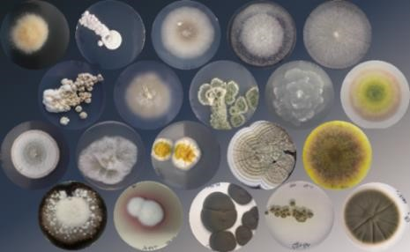
Figure 1. Photo collage of cultures from the collection of micromycetes isolated from mercurycontaminated sites. Copyright: Cristina Lorena Văcar.

Acknowledgements: This research is funded by grant of the Ministry of Research, Innovation and Digitization, CNCS - UEFISCDI, project number PN-IV-P1-PCE-2023-2016, contract no. 76PCE/2025 within PNCDI IV.





scan the program here

